

Course Name
Computer Programming Lab
Lab Title
Working in Python environment: Arithmetic Operations- Variables, and Data Type

Name | Registration Number | Lab #
Muhammad Hamzah Iqbal | F24604018 | 1
Date | Instructor’s Name | Instructor’s Signature
27/2/2024 | LE Ayesha Ashfaque

Objective:

- To have basic understanding to work in Python environment.
- Introduction to Variable
- To draw a flowchart, pseudo code of the given task.
- Introduction to data types in Python
- To write observations.

Theoretical Aspect

This lab introduces fundamental Python concepts, including arithmetic operations, variables, and data types. It emphasizes operator precedence, variable assignments, and string manipulation.

Experimental Procedure

Task 01: Calculate the area of a circle. Where the eq. is, Area = pi*(radius**2)

Pseudo Code:

Start
Assign value to the constants that will be used in the equation that is pie
Ask the user to input radius
Use the given formula to find the area of circle.
Display the result
Stop

Algorithm:

Assign the values to constants i.e. pi=3.14
Ask the user to input radius
Use given formula.
Area= pi*(radius**2)
Print the value stored in variable “area” in a string.
Flow Chart:
Start

Enter the radius:

Store Radius in r

Calculate Area using
Area = pi*(r^2)

Display Area

End

Task 02: Take a string from the user and find the length of the string. Hint: use (len) in-build function.

Pseudo Code:
Start
Ask the user to input a string
Use the built-in function to find the length of the string
Store the result in a variable
Display the length of the string
Stop

Algorithm:
Start
Ask the user to input a string
Store the input in a variable (e.g., text)
Use the length function to find the string’s length
Store the result in a variable (e.g., length)
Print the value stored in the variable length in a string
Stop

Start

Input a string

Store string in variable String.
Use len function to find length of string and then store it in length

Display the length of the string

End

Task 03: Join two strings taken by a user and display the output.

Pseudo code:

Start
Ask the user to input two strings separately
Add the two strings using ‘+’ operator
Store the result in a variable
Display the combined string
Stop

Algorithm

Start
Ask the user to input the first string
Store the first input in a variable (string1)
Ask the user to input the second string
Store the second input in a variable (string2)
Join string1 and string2 and store in result
Display result
Stop

Flowchart
Start

Ask user to input 2 strings separately

Add the 2 strings

Display the joined string result
End

Experimental Results

Task 1:

Code:

r=float(input("Enter the radius : "))
pi=3.14
area=pi*(r**2)
print("Area of the circle with radius ",r," is equal to : ",area)

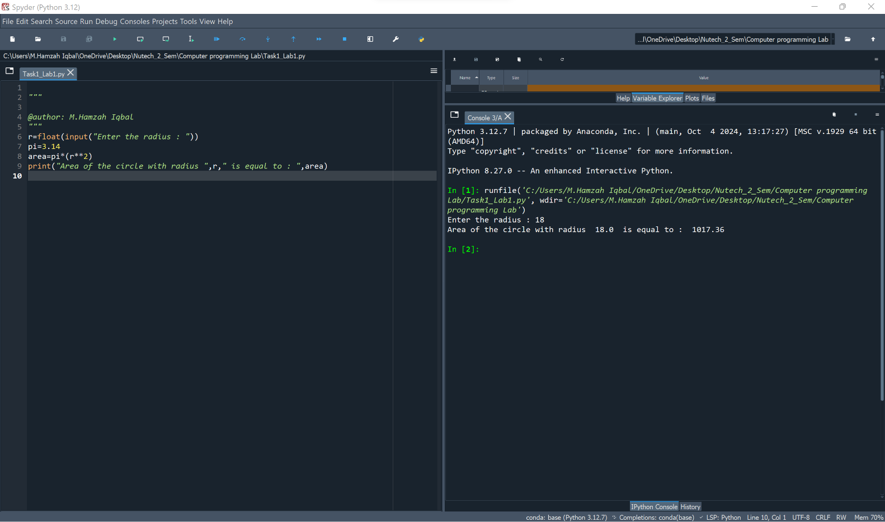
Figure 1 Finding Area

Task 2:

Code:

String=input("Enter a sentence : " )
length=len(String)
print("The length of the sentence you have entered is : ",length)

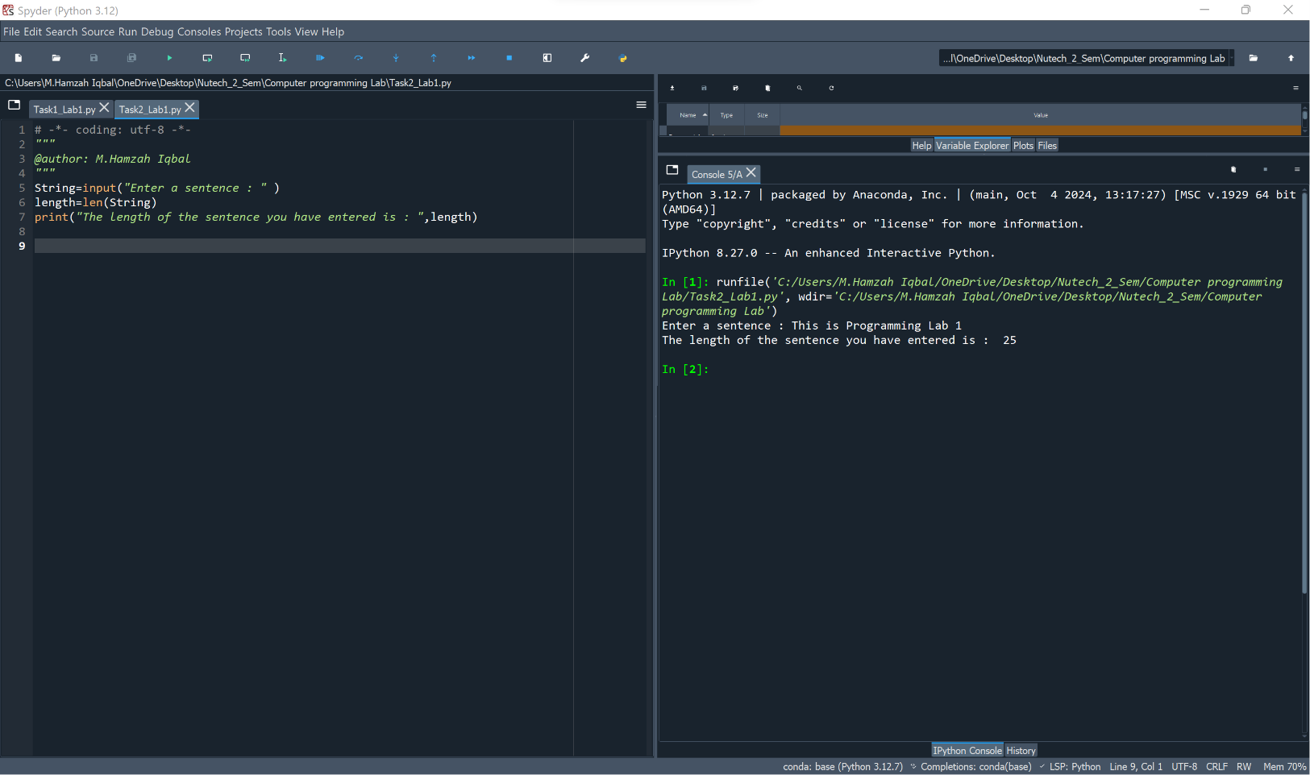

Figure 2 Finding Length of String

Task 3

Code
String_1=input("Enter a sentence : ")
String_2=input("Enter another sentence : ")
Together=String_1+String_2
print("Your Sentences combined together : ",Together)

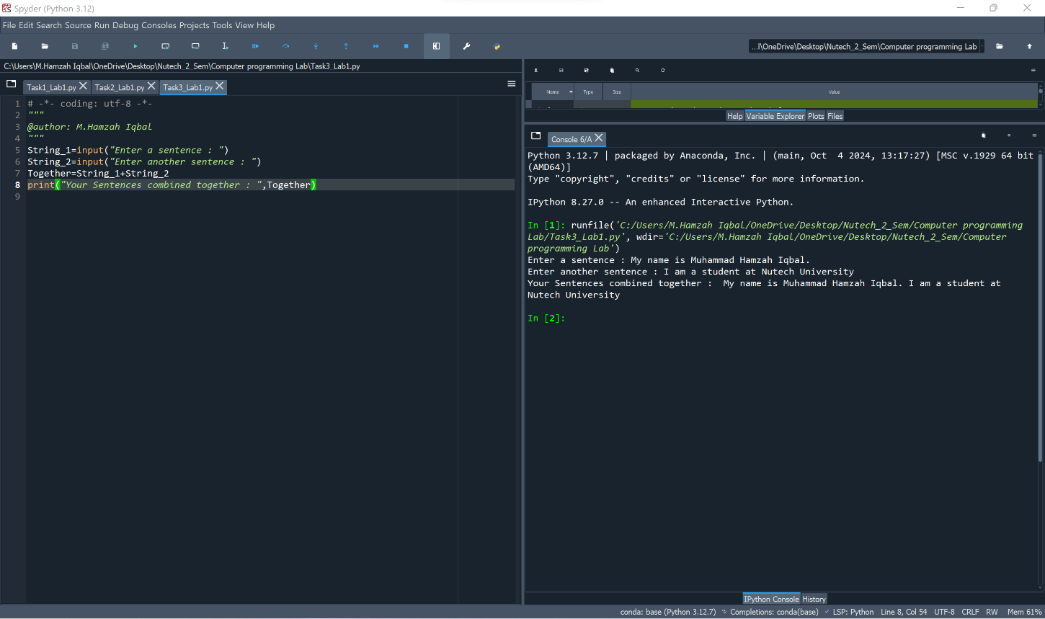

Figure 3 Combining Two Strings

Discussion of Results

In this lab, we performed three tasks using Python to explore basic programming concepts.

Task 1 (Area of a Circle): We used a predefined value of pi and a given radius to calculate the area using the formula Area = pi × (radius²). The result was displayed correctly, demonstrating how mathematical operations and variable assignments work in Python.

Task 2 (String Length): We took a user-input string and found its length using Python’s built-in len() function. This showed how we can efficiently determine the size of a string, which is useful in text processing applications.

Task 3 (String Concatenation): We took two strings from the user and joined them using the + operator, illustrating how Python handles string manipulation. This concept is widely used in formatting and text-based applications.

Conclusions

This lab introduced fundamental programming skills, including mathematical calculations, string handling, and user input processing in Python. By applying these techniques, we gained practical experience in handling variables, functions, and operations that are essential for programming and real-world applications like data processing and automation.

